Manuscript Template of Spektra-The Title of Your Paper Written by Capital Letters Each Words
(Use Microsoft Word template style: Paper Title)
Name of First Author^{1,a)}, Name of Second Author^{2,3,b)}, etc
(Use Microsoft Word template style: Paper Author)
¹ Replace this section with affiliate / institutions Writer (Use the complete address). Superscript "a)" shows the author email address below. Use b), c), etc. to show the e-mail address if the author of more than one.
² Additional address dtuliskan affiliation with superscript 2, 3, and so on. as indicated above.
³ Additional affiliation address, and so on. .
(Use Microsoft Word template style: Author Affiliation).
Email: ^{a)}firstauthor@emailaddress.ac.id, ^{b)}firstauthor@thisaddress.org, dst
(Use Microsoft Word template style: Author Email)
Abstract
Write the abstract (English version) in this section. SPEKTRA manuscript template provides a style that can be applied directly on your writing. For the words "Abstract" in the title above, use the style Abstract-Title, while for the content using style: Abstract. If manuscript written in English, the author can only write abstract english version only. Please write abstract no more than 250 words. The length of the article are 6-12 pages A4 size.
Keywords: write down keywords here.

HEADING LEVEL ONE, TWO, AND THREE (HEADING LEVEL ONE)
(Use Microsoft Word template style: Heading 1)
This document is a SPEKTRA manuscript template in Microsoft Word. In this section we will explain the example of writing your paper.
In this section we will explain the example of writing your paper. Heading level 1 eg INTRODUCTION, METHODS, RESULTS AND DISCUSSION, CLOSING/ CONCLUSION/ SUMMARY, ACKNOWLEDGMENTS, REFERENCES. While Heading level 2 is a sub-section of Heading Level 1. You can write it as needed. Here, there will be explained the use paragraph styles for Heading Level 1, Level 2, and Level 3, as follows:
- In this template we write Heading Level 1, 2, or 3, as an example "(Heading Level 2). " This is just a hint, you do not have to write it in your article.
- Under Heading we write the style used by the font color red - for example, "(Use the Microsoft Word template style: Heading 2)." This is also an indication that is not part of the Heading and should be removed from your article. The purpose of these instructions is to facilitate the author in determining the style in the article
- For paragraphs, use Microsoft Word template style: Paragraph.
Do not input any headers and footers, including the page number in your article. All headers, footers, and page numbers will be added by the SPEKTRA editor.

How to Implement Paragraph Style (Heading Level 2)
(Use Microsoft Word template style: Heading 2)
Here will be explained how to bring up a pop-up window to select a style:

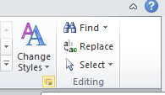  Click on this section to display a pop-up window containing the SPEKTRA style template.  To apply it, highlight the paragraph or place the cursor in any part of the paragraph, then click Paragraph Style in the pop-up window list. | 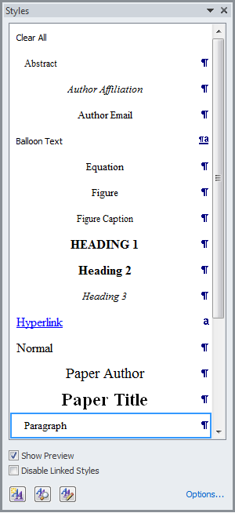

How to Use SPEKTRA Templates (Heading Level 2)
(Use Microsoft Word template style: Heading 2)
You can remove or replace the contents of this template and place your image or table, while still applying the Style in the Window pop-up. And make sure, the descriptions or hints of this template are removed when you submit the article.

Heading to Capital Each Words and Bold (Heading Level 2)
(Use Microsoft Word template style: Heading 2)
Except for the conjunction, the first letter of each word is capital, Heading Level 2 and Level 3. This new paragraph appears when you press the button [ENTER].

Heading to Capital Each Words and Italic (Heading Level 3)
(Use Microsoft Word template style: Heading 3)
Except for conjunction, the first letter of each word is capital for Article Title, Heading Level 2 and Level 3. This new paragraph appears when you press the [ENTER] key

MATHEMATICAL EQUATION (heading LEVEL 1)
(Use Microsoft Word template style: Heading 1)
In this section we write some basic formats for writing mathematical equations. The written mathematical equations should use standardized symbols.

Format and Insert Equation (Heading Level 2)
(Use Microsoft Word template style: Heading 2)
Equations should be placed in the middle with his right equation number (flush right). Here are tips on writing an equation in accordance with the template SPEKTRA:
- Copy, paste, and edit examples of Equation (1) below (very are suggested).
- Manually enter the equation, via the MathType menu.
- Edit the number of equations.
- Before you manually enter the equation or edit the number of equations please install the MathType. Please download how to install MathType by access
http://journal.unj.ac.id/unj/index.php/spektra/equation

OTHER SPECIFICATIONS (heading LEVEL 1)
(Use Microsoft Word template style: Heading 1)
Figures and tables.

Figures (Heading Level 2)
(Use Microsoft Word template style: Heading 2)
If you view multiple pictures, you can use table.

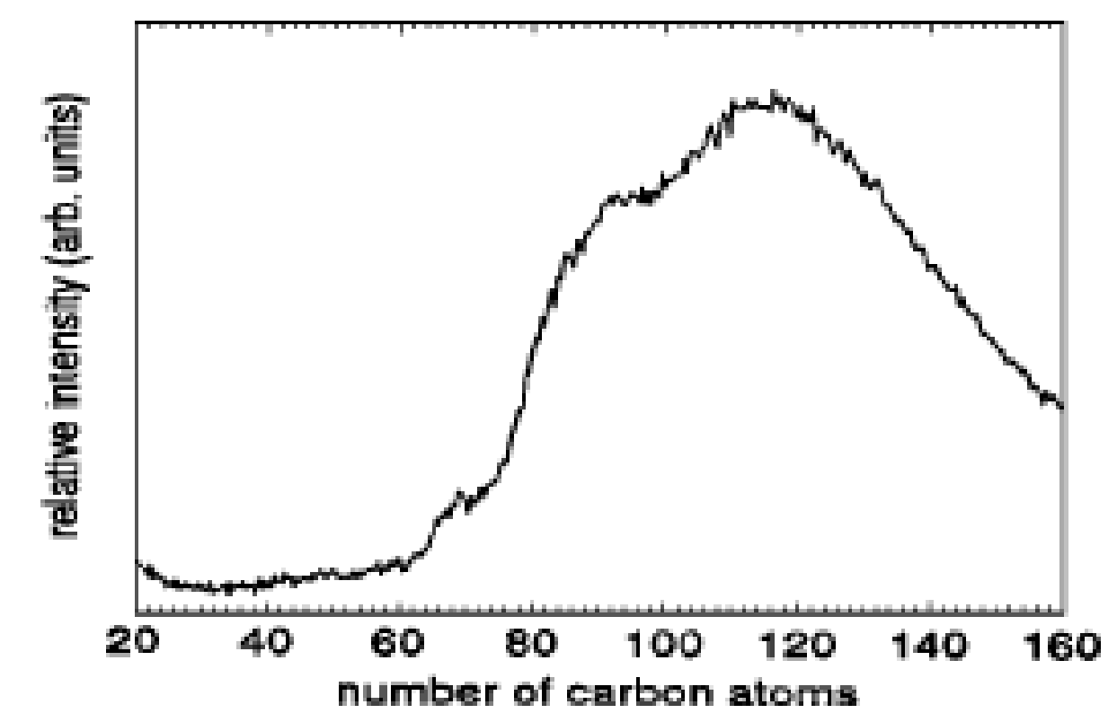 | 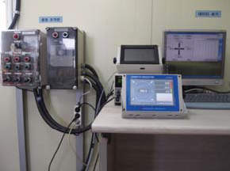
(a) | (b)
FIGURE 1. Use Microsoft Word template style: Figure Caption. Writing "FIGURE 1," which is the label must be written in capital and bold Times New Roman size 9. If the image has a lot of parts, you can use the label (a), (b), and so on. Using tables, arranging the location of images with many parts becomes easier as the example above.

For mention figure above in paragraph, write down as FIGURE 1, please use capital letter for the name of figure.

Table (Heading Level 2)
(Use Microsoft Word template style: Heading 2)
Here we list examples of the writing table, shown in TABLE 1. Please remove any vertical lines in your table.
TABLE 1. Use Microsoft Word template style: Table Caption. Writing "TABLE 1," is the label description table,bold, and capital. Description flat table placed above the middle of the table.
Column Header | Column Header | Column Header
Row 1 | x | x
Row 2 | x | x
Row 3 | x | x

TIPS CHECKING THE ARTICLE (heading LEVEL 1)
(Use Microsoft Word template style: Heading 1)
Some tips to do a final check of your article before it is submitted to SPEKTRA:
- Write down your paper using SPEKTRA Manuscript Template.
- Make sure you save as Microsoft Word 1997-2003.
- Create PDF files from your article

HOW CITATION – IEEE SYSTEM
(Use Microsoft Word template style: Heading 1)
You can delete this section after finished reading. The name and the author may be written in square brackets and a continue number [1]. Make sure that the way you refer to/quote the sentence and how to write it in the reference list in accordance IEEE System, IEEE explanation file system in a separate file [2]. Note also that the different ways of reference for books, journals, and other sources.

Acknowledgments
(Use Microsoft Word template style: Heading 1)
Write the acknowledgments, examples of writing is: for research funders, agency/ person who helped/ contributes research, please don’t write any author name in this section.

Referensi
(Use Microsoft Word template style: Heading 1)
References used by SPEKTRA is the IEEE system. In the list of references, sort (ascending) alphabetically by the author's last name. Please using the Reference Style.
- J. K. Author, “Title of chapter in the book,” in Title of His Published Book, xth ed. City of Publisher, Country if not USA: Abbrev. of Publisher, year, ch. x, sec. x, pp. xxx–xxx.
- J. K. Author, “Title of report,” Abbrev. Name of Co., City of Co., Abbrev. State, Rep. xxx, year.
- Name of Manual/Handbook, x ed., Abbrev. Name of Co., City of Co., Abbrev. State, year, pp. xx-xx.
- J. K. Author, “Title of paper,” in Unabbreviated Name of Conf., City of Conf., Abbrev. State (if given), year, pp. xxx-xxx.

